HybridFEM MATLAB/Simulink Manual

The HybridFEM program runs under MATLAB and Simulink (R2007b) and is compatible with Target PC for real-time applications. It consists of a Structure, Elements and an Integrator for running the pseudo-dynamic simulation. The included Example System contains all the files necessary for running a local simulation using MATLAB and a real-time simulation using SIMULINK and xPC.

Installation and Usage
Copy the HybridFEM folder anywhere on your computer. In MATLAB, add the path to the HybridFEM location using File – Set Path. Run the program from a HybridFEM “system” folder.

Inside the base code
The HybridFEM program consists of many MATLAB M-files and a MDL Simulink library file. It is also packaged with two examples under the Systems folder.
- CalculateBandwidth.m: Calculates the bandwidth of the Structure for use in calculating the stiffness matrix.
- CalculateMatrices.m: Forms the integration matrices.
- CreateElement_TypeN.m: Creates each type of Element object.
- CreateIntegrator.m: Creates the Integrator object.
- CreateMaterial.m: Creates the Material object inside an Element.
- CreateNode.m: Creates a single Node object with coordinates.
- CreateStructure.m: Creates a Structure object.
- FormElementMatrices_TypeN.m: Forms the Element matrices per type.
- GenerateCommands.m Generates the Command vectors (only for the LocalSimulator).
- GetEQHistory.m Loads the earthquake acceleration record.
- GetRestoringForce_TypeN.m: Calculates the restoring force for that element (only for the LocalSimulator).
- InitializeIntegrator.m: Initializes the memory used for the integration algorithm.
- LoadConfiguration.m: Reads the INP configuration file and sets up the Structure, Element and Integrator objects.
- UpdateAcceleration. Updates the acceleration vector and gets the next time step effective force (only for the LocalSimulator).
- HybridFEMSetup.m: Uses all the files above to configure a complete Hybrid FEM system for use with the Simulink library available.
- HybridFEMLibrary.mdl: The Hybrid FEM Simulink library which contains all the available blocks to complete a system for simulation.

Local Simulation
The HybridFEM program consists of an M-file for running local simulations within MATLAB. In the Example System, the file, “LocalSimulator.m” contains the code to run the local simulation. The user must edit the file first and set the input configuration file and the earthquake history file. Running this file will produce a plot of the displacement and restoring force results.

Real-time Simulation
The HybridFEM program has the capabilities of running models in real-time using SIMULINK and xPC. In the Example System, the file, “RealtimeModel_Setup.m” contains the code to set up the system and the file, “RealtimeModel,mdl” contains the SIMULINK blocks that run the integration algorithm and compute the restoring forces. The model is multi-threaded meaning that the integration time step is a multiple of the fundamental sample rate. This allows for actuator ramping at the fundamental sample rate which the complex integration algorithm performs its calculations over the full time step.

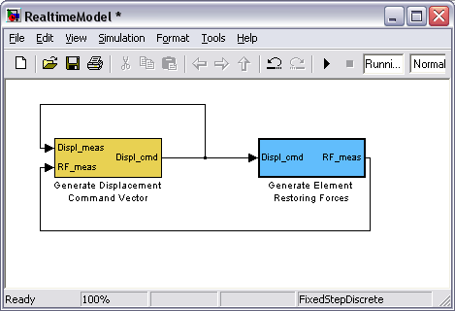

In the above system, the yellow block, “Generate Displacement Command Vector” represents the CR Integration algorithm. It generates the displacement command and accepts the measured displacement and total restoring force as inputs. It connects to the “Generate Element Restoring Forces” block which performs the per element restoring force calculations.

To interface with this model, the user can tap the displacement output from the “Generate Displacement Command Vector”. Also, the “Generate Element Restoring Forces” can be modified to allow restoring force input(s) from real systems.

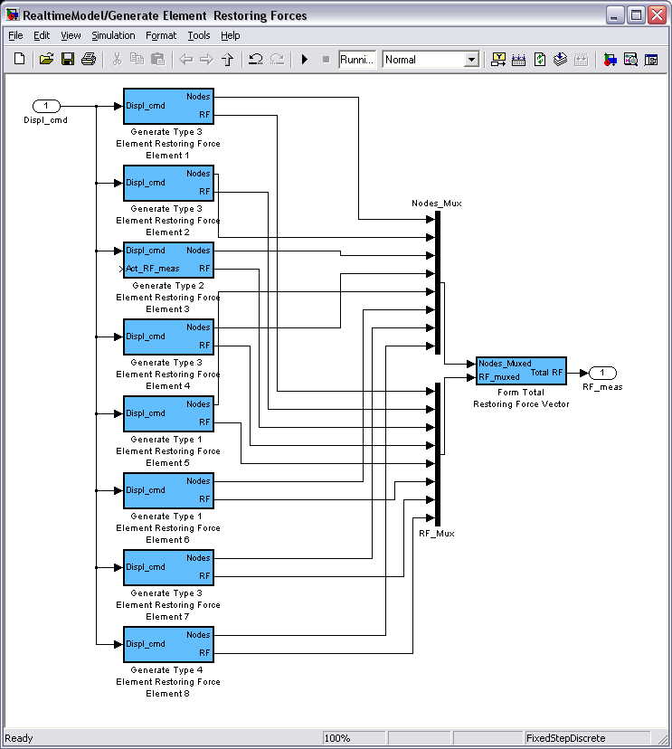

Each element block takes the displacement command from the Integrator as an input and produces a restoring force. Element 2 has an extra input for using an experimental restoring force instead of generating it internally. A SIMULINK inport block can be used to tap this signal. The outputs of the elements need to be muxed as a group of Nodes and a group of restoring forces. These are then inputs for the “Form Total Restoring Force Vector” block, which takes all the element restoring forces and generates the global restoring force vector for the system.

